Mail Server

📧 What is a Mail Server?
# Source: AI Source: Provided by: [Data Path: Persons Table -> ID Column: 1, Name_En Column: Motasem Essam] -> From: [ChatGPT] on [1/16/2026]
A Mail Server is a computer or program that sends, receives, stores, and delivers email messages. It works like a digital post office, handling messages between users and other servers on the internet.

🧠 Simple Explanation:
# Source: AI Source: Provided by: [Data Path: Persons Table -> ID Column: 1, Name_En Column: Motasem Essam] -> From: [ChatGPT] on [1/16/2026]
When you send an email:
- Your mail client (like Gmail or Outlook) contacts the mail server.
- The server delivers your message to the recipient's mail server.
- The recipient then uses their own mail client to retrieve it.

🔄 Types of Mail Servers:
# Source: AI Source: Provided by: [Data Path: Persons Table -> ID Column: 1, Name_En Column: Motasem Essam] -> From: [ChatGPT] on [1/16/2026]

Server Type | Protocol | Purpose
SMTP Server | SMTP (Simple Mail Transfer Protocol) | Sends outgoing emails to other servers
POP3 Server | POP3 (Post Office Protocol v3) | Downloads emails to a local device
IMAP Server | IMAP (Internet Message Access Protocol) | Manages and syncs email across devices

📬 Email Flow (Basic Steps):
# Source: AI Source: Provided by: [Data Path: Persons Table -> ID Column: 1, Name_En Column: Motasem Essam] -> From: [ChatGPT] on [1/16/2026]
- User sends email → Mail client uses SMTP to send it.
- Sender’s mail server forwards the email to recipient’s server.
- Recipient checks email → Mail client uses IMAP or POP3 to fetch it.

🧩 Components of a Mail Server System:
# Source: AI Source: Provided by: [Data Path: Persons Table -> ID Column: 1, Name_En Column: Motasem Essam] -> From: [ChatGPT] on [1/16/2026]
Component | Role
Mail Transfer Agent (MTA) | Sends and receives emails (e.g. Postfix, Sendmail)
Mail Delivery Agent (MDA) | Delivers email to user’s inbox (e.g. Dovecot)
Mail User Agent (MUA) | The client that users interact with (e.g. Outlook)

🛡️ Optional Add-ons
# Source: AI Source: Provided by: [Data Path: Persons Table -> ID Column: 1, Name_En Column: Motasem Essam] -> From: [ChatGPT] on [1/16/2026]
Add-on | Function
Spam filter | Block junk emails
Antivirus | Scan for malicious attachments
Webmail | Access email through browser

How to set up a basic mail server?
# Source: AI Source: Provided by: [Data Path: Persons Table -> ID Column: 1, Name_En Column: Motasem Essam] -> From: [ChatGPT] on [1/16/2026]
A basic mail server setup includes 3 key parts:
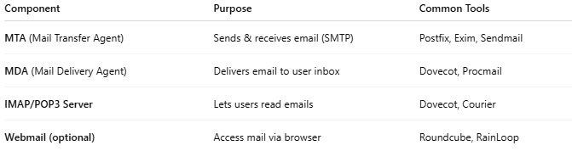

Component | Purpose | Common Tools
MTA (Mail Transfer Agent) | Sends & receives email (SMTP) | Postfix, Exim, Sendmail
MDA (Mail Delivery Agent) | Delivers email to user inbox | Dovecot, Procmail
IMAP/POP3 Server | Lets users read emails | Dovecot, Courier
Webmail (optional) | Access mail via browser | Roundcube, RainLoop

⚙️ Common Setup (Linux-based VPS)
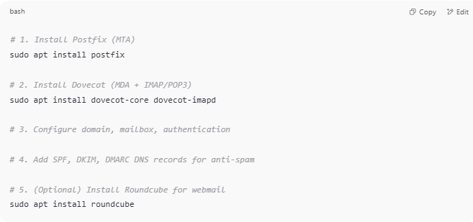
# 1. Install Postfix (MTA)
sudo apt install postfix

# 2. Install Dovecot (MDA + IMAP/POP3)
sudo apt install dovecot-core dovecot-imapd

# 3. Configure domain, mailbox, authentication

# 4. Add SPF, DKIM, DMARC DNS records for anti-spam

# 5. (Optional) Install Roundcube for webmail
sudo apt install roundcube

You’d also set:
- MX records in DNS to point to your mail server
- SSL/TLS certificates for secure access (Let's Encrypt or manual)
Would you like a full guide for a specific OS like Ubuntu?

How Webmail (like Roundcube or Gmail) Connects to Mail Servers

🧭 Roundcube (or Gmail) acts as a Mail Client (MUA)
# Source: AI Source: Provided by: [Data Path: Persons Table -> ID Column: 1, Name_En Column: Motasem Essam] -> From: [ChatGPT] on [1/16/2026]

Action | Protocol Used | Connected To
To send email | SMTP | Mail Transfer Agent (e.g., Postfix)
To read email | IMAP (or POP3) | Mail Delivery Agent (e.g., Dovecot)

🔁 Example Flow (for Roundcube):
# Source: AI Source: Provided by: [Data Path: Persons Table -> ID Column: 1, Name_En Column: Motasem Essam] -> From: [ChatGPT] on [1/16/2026]
- User logs into Roundcube via browser
- Roundcube connects to IMAP server (e.g. Dovecot) to fetch emails
- When user sends an email, Roundcube submits it via SMTP to Postfix
- Postfix sends it to the recipient’s mail server over the internet

🛡️ Gmail Example (External Mail Client):
# Source: AI Source: Provided by: [Data Path: Persons Table -> ID Column: 1, Name_En Column: Motasem Essam] -> From: [ChatGPT] on [1/16/2026]
If you connect Gmail to your own mail server:
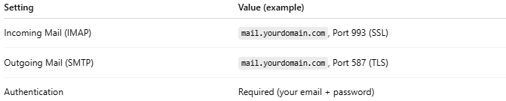

Setting | Value (example)
Incoming Mail (IMAP) | mail.yourdomain.com, Port 993 (SSL)
Outgoing Mail (SMTP) | mail.yourdomain.com, Port 587 (TLS)
Authentication | Required (your email + password)

✅ Summary
# Source: AI Source: Provided by: [Data Path: Persons Table -> ID Column: 1, Name_En Column: Motasem Essam] -> From: [ChatGPT] on [1/16/2026]
Feature | Description
Purpose | Send and receive emails
Key protocols | SMTP, IMAP, POP3
Used by | Email providers, businesses, mail apps
Components | MTA, MDA, MUA, filters, webmail

